**Department of Information Systems and Cyber Security University of Texas in San Antonio**



IS 3413: Telecom and Networking-001, Fall, 2022

Name: Daniel Cook  
UTSA ID: dhz799  
Email address: *danielwcook5@gmail.com*

Lab Assignment: Lab: M01 – Wireshark Introduction  
Date Due: 9/3/2022  
Date Submitted: 9/2/2022

Section A, Question 1: What is this IP address and what device does it represent?

The source is the address where the packets originated, and the destination is which the packets are being sent with the following being returned.Which appears to be sent to a web address through TCP. (I searched up my.utsa.edu)

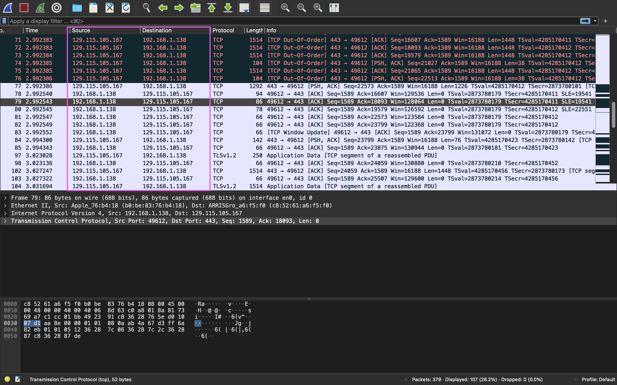

Section A, Question 2: Examine the Protocol column in the Packet List pane. Just estimating by scrolling through the packets, what protocol seems to be listed most of the Wireshark window at this point with your response.

The protocol that seems to be used the most is TCP (Transmission Control Protocol), during this time I searched up my.utsa.edu

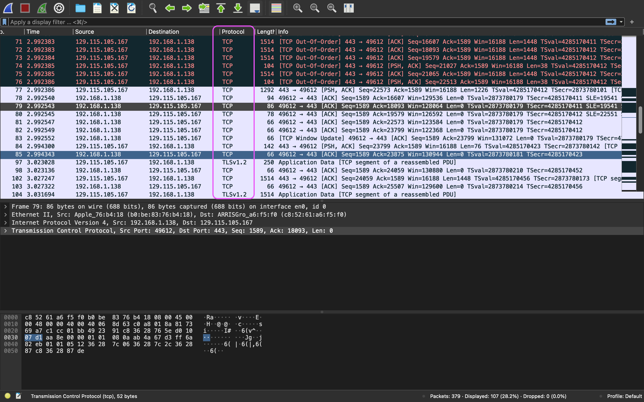

Section A, Question 3: Look at the information provided and identify which layers of the Internet/OSI model rows 2, 3 and 4 correspond to.

Data link Layer (Ethernet II) is row 2, which shows the devices with the following addresses. Network Layer (Internet Protocol Version 4) is row 3, which shows the source and destination IP addresses. Transport Layer (Transport Control Protocol) shows the source and destination ports, with the TCP sequence, acknowledgement, and length.

